## **Creating DotNetCore Web API using the DotNet CLI**

1- Command needed to create the web api project in CLI



Once the DatingApp.API project is created you will see the contents as below

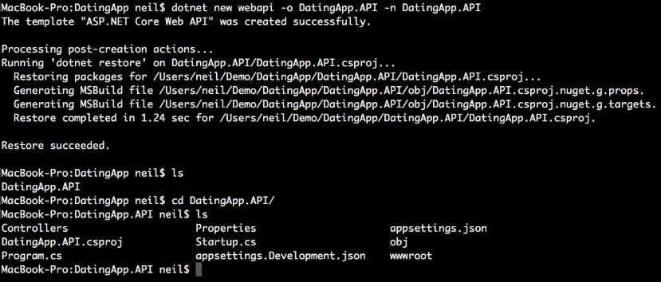

2- Helpful extensions needed which can be installed in Visual Studio Code

* C# for Visual Studio Code (powered by OmniSharp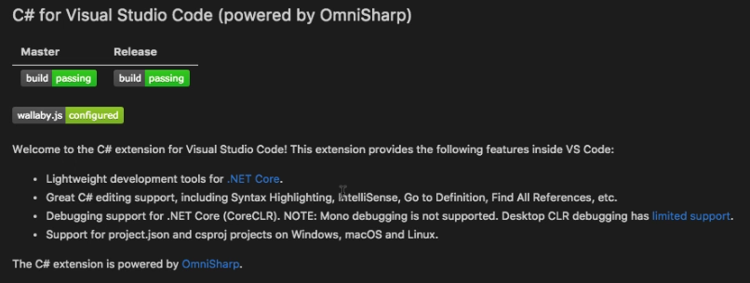
* C# extensions

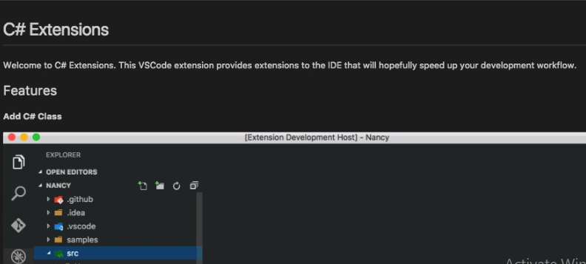

* Nuget package manager

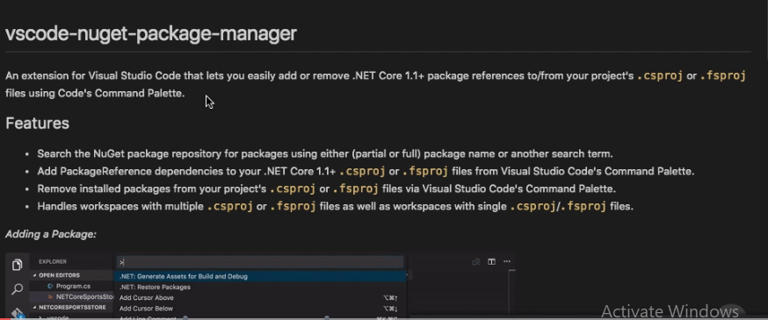

* as